BEEE – LAB EVALUATION

Circuit Diagram :-

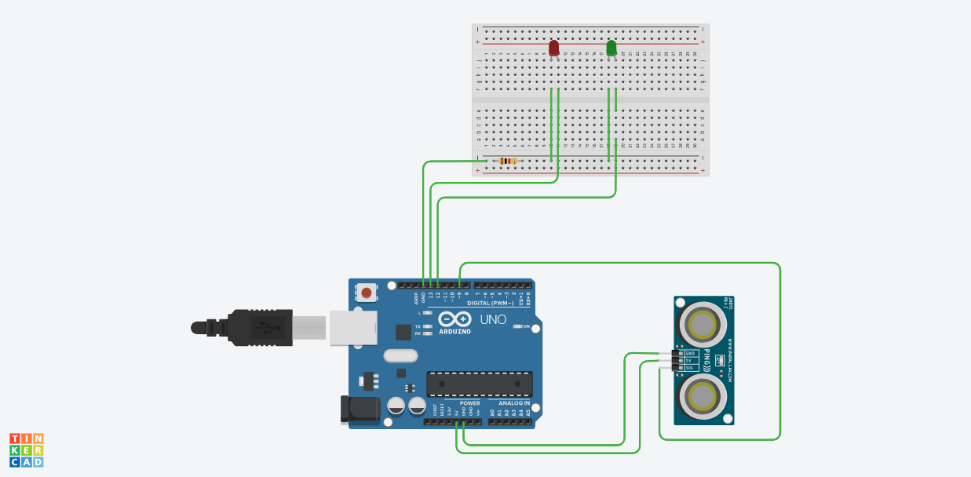

Theory :-

In this project , I have used an ultrasonic sensor for measurement of the distance . This project can be used for detecting obstacles coming infront of car while driving . When any obstacle comes infront of the car, the red light(LED) starts blinking and when obstacle is near or at back then green LED starts blinking .

In this Arduino is exploring its application of obstacle detection and finding distances . Arduino can be widely used in future for its distance measuring and other applications and will be more helpful in automation.

Problems and Troubleshooting :-

In the completion of this project , I faced some problems while simulating . When I started simulating , then I was not able to change distances . Then my friend help me to get out of this problem . To change distance , click on ultrasonic sensor and drag/move the cursor/object . this will change the distance and program will run effectively .

Precautions :-

One should not disturb the circuit while simulation .

Circuit should be correct.

Drag the cursor/object carefully to get the proper readings .

Learning Outcomes :-

In this project we will come to know about the distance measuring application of Arduino through ultrasonic sensor . This will be helpful in generating things to detect obstacles .

Also this help you in building a fair idea about distance measuring through Arduino.

Thank You